# Shell Script Assignment

**Mandatory:**

1. Create a script named “myscript” in current directory to do the following.
2. display “hello user”

* #!/bin/bash/

echo “hello user”

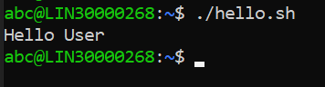

1. list files in current directory

* #!/bin/bash/

ls



1. name of logged in userg

* #!/bin/bash/

w

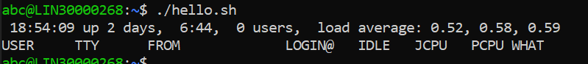

1. date

* #!/bin/bash

date



1. Add execute permission and Run the script from
2. current directory
3. Create a subdirectory named “test”

* #!/bin/bash

mkdir -p test1/test

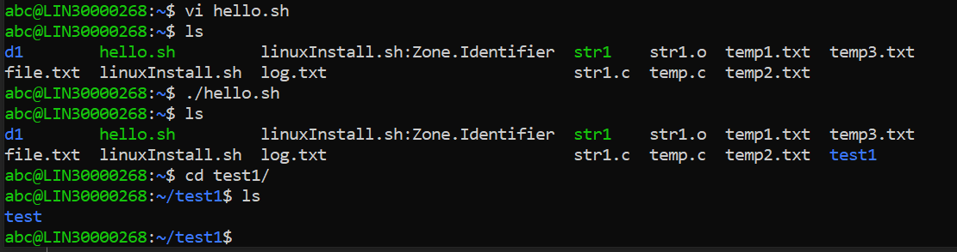

1. Change to “test” directory. Run the script “myscript” [Hint: You will have to update PATH to include the directory containg script to run script from any location].